Create task

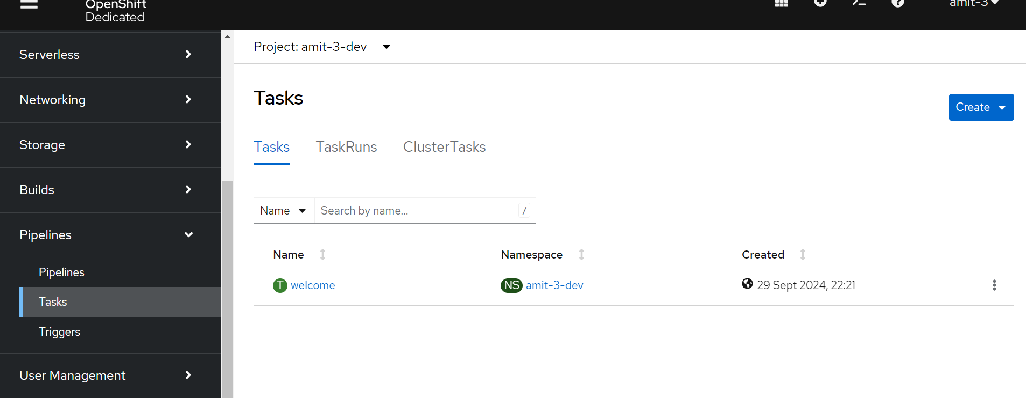

Click on create task🡪 replace the yaml

apiVersion: tekton.dev/v1beta1  
kind: Task  
metadata:  
 name: welcome  
spec:  
 params:  
 - name: user  
 description: user name.  
 default: john.doe  
 type: string  
 steps:  
 - name: echo  
 image: alpine  
 script: |  
 #!/bin/sh  
 echo "Welcome $(params.user) to tekton pipelines"

Create one more task

apiVersion: tekton.dev/v1beta1  
kind: Task  
metadata:  
 name: testing  
spec:  
 params:  
 - name: user  
 type: string  
 steps:  
 - name: echo-testing  
 image: ubuntu  
 script: |  
 #!/bin/bash  
 echo "User '$(params.user)' is running some tekton tests!"

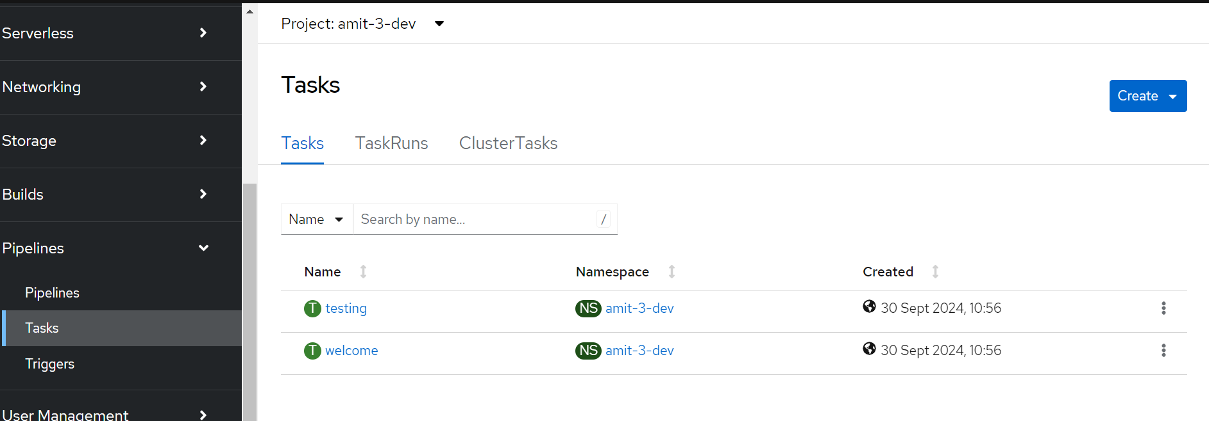

Now we are going to create our pipeline object referring to all the tasks that we want to run. Open your favorite editor and paste the following content:

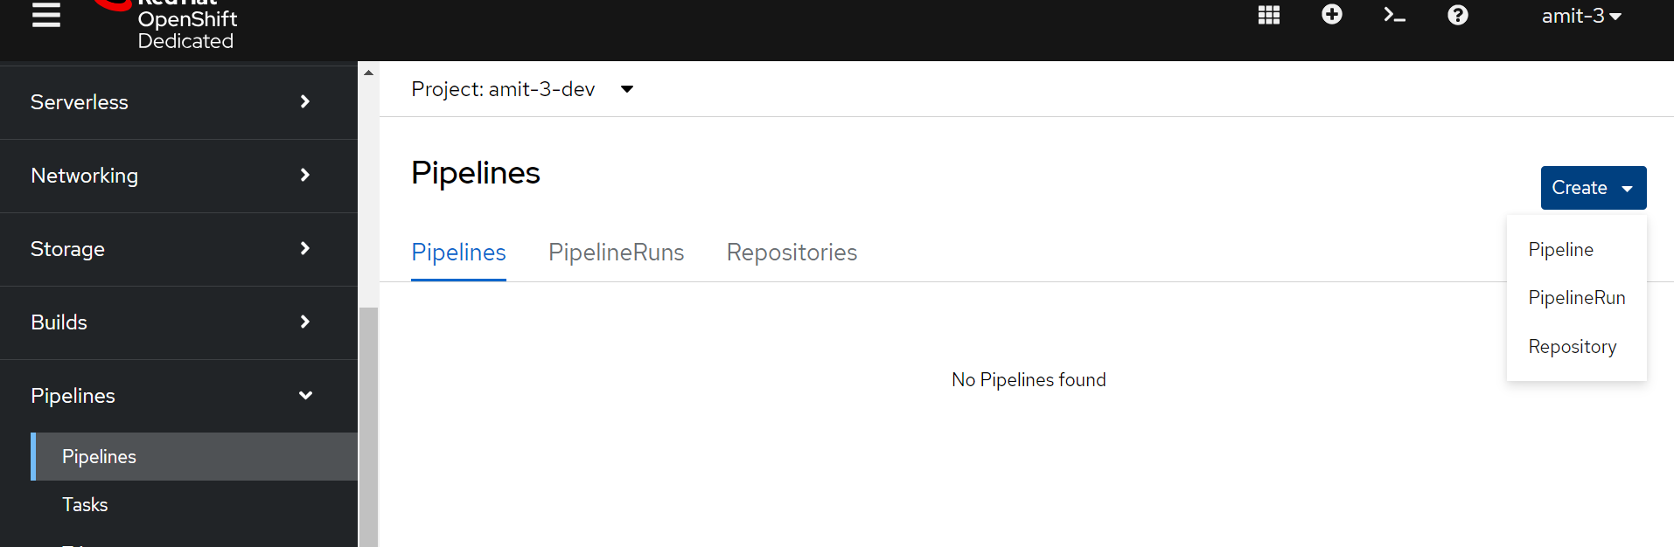

apiVersion: tekton.dev/v1beta1  
kind: Pipeline  
metadata:  
 name: demo-pipeline  
spec:  
 params:  
 - name: username  
 type: string  
 tasks:  
 - name: welcome  
 taskRef:  
 name: welcome  
 params:  
 - name: user  
 value: $(params.username)  
 - name: testing  
 runAfter:  
 - welcome  
 taskRef:  
 name: testing  
 params:  
 - name: user  
 value: $(params.username)

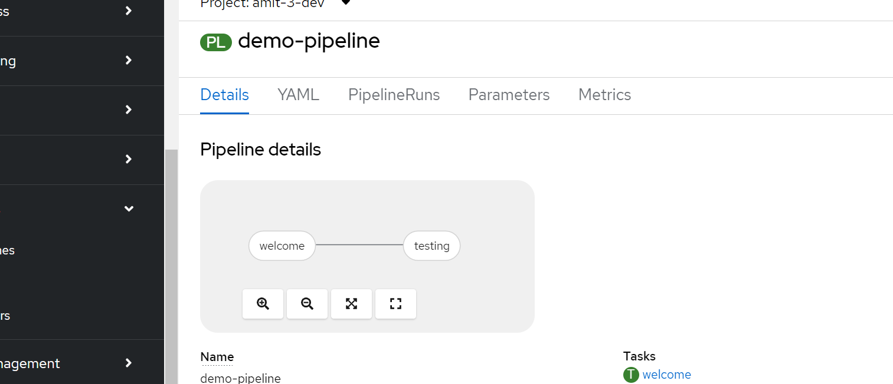

Pipeline run

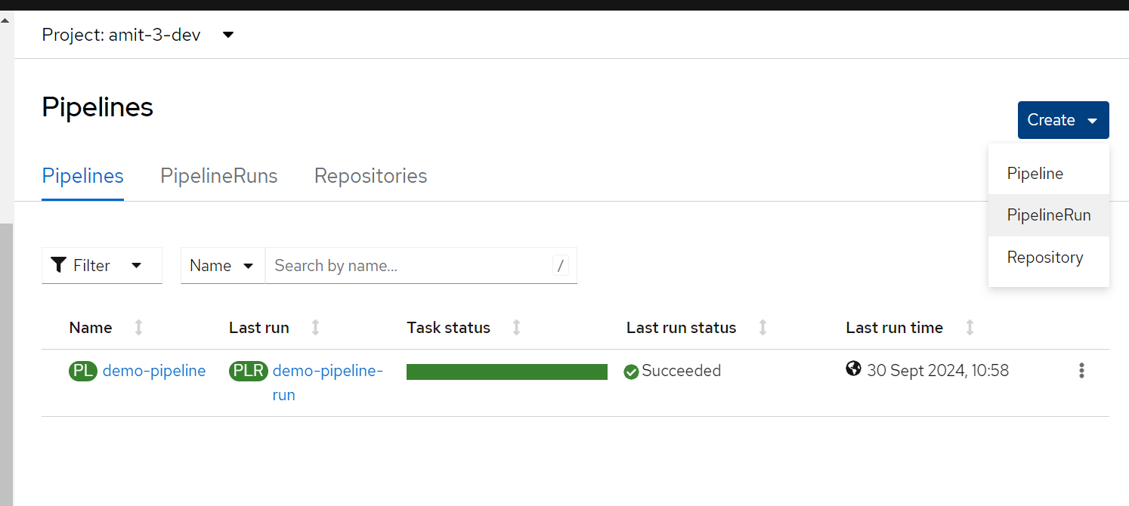

apiVersion: tekton.dev/v1beta1  
kind: PipelineRun  
metadata:  
 name: demo-pipeline-run  
spec:  
 pipelineRef:  
 name: demo-pipeline  
 params:  
 - name: username  
 value: "Tekton"

